Images for numbers 10-99
This document accompanies the podcast, "Remember Word4Word," and provides sample images for numbers from 10 to 99, forming the third part of the Major System.
The first part described how numbers 0-9 could be represented by images based on
10 sounds that consonants make. The second part described how to create double
numbers with an example exercise in pi.
This part covers sample images for the numbers 10-99. These are just samples, and feel free to use your own images - it doesn’t matter what image you end up with, but you must follow the Major Rules to get there. The only exception would be if you already have a strong image for any of these numbers. But it must be an exception- following the rules also strengthens your memory for those initial 10 numbers, as you may have noticed when we did pi.
This is how we create an image following the Major rules EXAMPLE - Images for Number 11
1 is represented by t or d. 11 is therefore t*t or d*d. Trying these consonants with the 5 vowels gives:
t*t..... tat....tet.....tit.....tot. tut
t*d..... tad....ted.....tid.....tod. tud
d*d..... dad....ded.....did.....dod dud
d*t..... date....det.....dit.....dot dut
If you add an e at the end, such as in date, you get even more words, and yet you are still following the Major System rules.
All the above words follow the basic rule for 11. But the ones that give the strongest images are tit, tot, ted, dad.
Choose one that gives you the strongest picture and one that your brain cannot misinterpret as representing anything other than the number 11.
I mostly use TOT because a small child is unlike any other image I have, but occasionally I will use DAD. TED, as someone you know called Ted, Father Ted, or a teddy bear, would also work well.
After learning the basic 10 numbers, it should not be hard to remember the images for the following 90, as you can guess your number image by trying out each of the 5 vowels between the 2 consonants.
Images for the Major System 10 - 99

This is a list of suggested images for 10 to 100 and how they could be used in your visualizations.

10 Toes
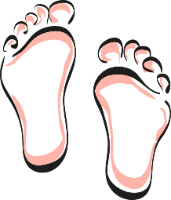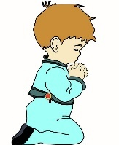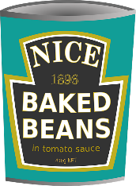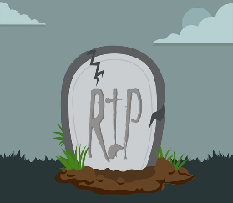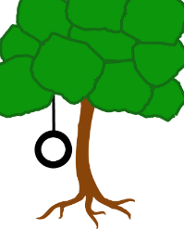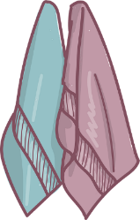
T z – remember 0 – saw or zoo
Big hairy toes. Smartly painted toenails. Any picture that says 'toes' to you.
For some reason, I had difficulty coming up with a strong picture for toes. If this happens to you, relax, and ask yourself if there is any image that does come up for this word. For me, it was Dopey from Snow White, whom I saw as not wearing shoes. It was a great image for whenever I want 10, I have Snow White and/or the Dwarves dancing through my mind. The odd thing is, when I checked, Dopey does wear shoes. It does not matter, now, my image is attached to 10, and it began with the rule. Do not be tempted to make up arbitrary images for your numbers. It is just making it all much more difficult than it needs to be. Whatever image you choose, you MUST be able to clearly trace it back to the original number, which follows the Major System rule. I will make a note of where I have deviated from the rule, so you will see what I mean.

11Tot - A small child

12 Tin - Tin container or Tin of baked beans, Tin of Tomato Soup.

13Tomb - Tomb or Gravestone

14Tyre - Tyre on a car, rolling a tyre, swinging in a tyre, or the Michelin Man.
15 Towel - Wrapped around someone, lie on it - even think Hitchhiker's Guide to the Galaxy
Galaxy'.

16 Dish – put things in it, bake in it

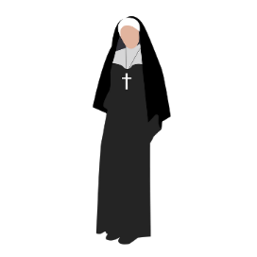
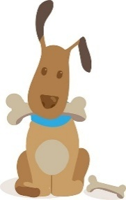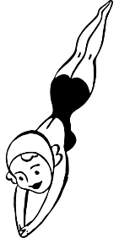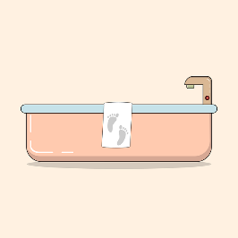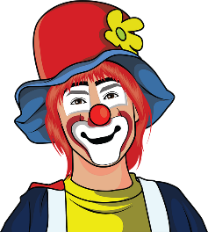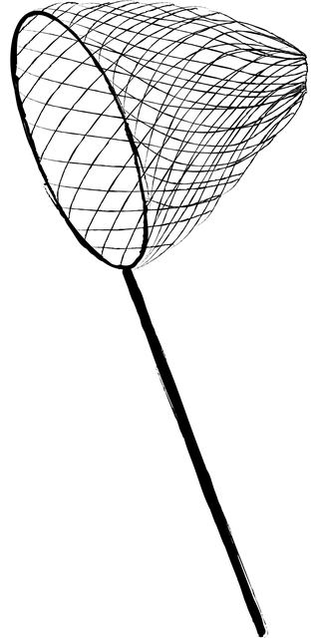

17 Deck/Dock/Dog – A deck is useful because things can happen on it. If you choose this, make sure you do not confuse your image with 'ship' 6-9.

18 Dive - Useful because people can dive off anything.

19 Tub - Useful because, besides bathing, you can put things in it, such as coal.

20 Nose - I use the symbol of Pinocchio for 20. I make his nose grow long and perch things on it. I also often use a clown's red nose, as in Red Nose Day.

21 Net - Useful for catching things or festooning stuff.

22 Nun - Strong image.

23 Name -This was another word I had difficulty creating an image for. Then I asked myself what 'name' meant to me, and I thought of the image of an aeroplane writing a name in the sky. It worked for me, and the symbol has now become just an old-fashioned biplane; I put people in it, make them balance on the wings, and throw things out of it, but remember, I did not start with a plane; I started with a name. You must have a logical reason tied to the Major Rule for your image.
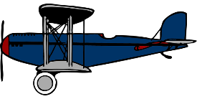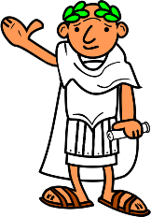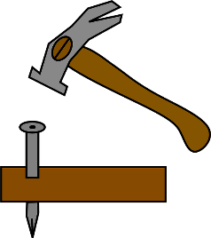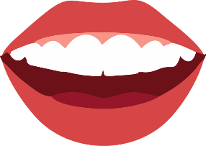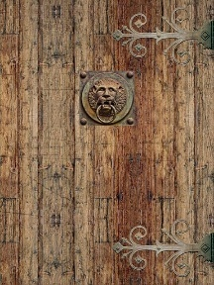
24 Nero - I have an image of a Roman in a toga.

25 Nail - Bang it into things. Hang things on it.

26 (G)Nash - I use an image of teeth – often false teeth or the joke ones that chatter.

27 Knock - Knock loudly on the door. Door knocker (Marley from 'A Christmas Carol'). Make connections: Beethoven died in 1827 – the first chords of the 5th Symphony are supposed to evoke Fate knocking (27, knock).
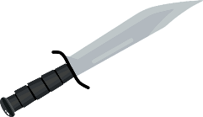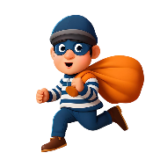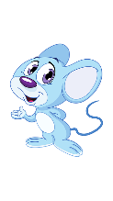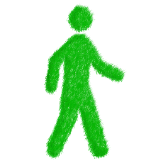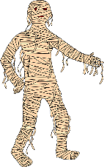
28 Knife - Cut with it, stab with it, or throw it.

29 Nab/nob/nib - I often have a picture of a burglar nabbing something and running away. So I have a picture of a stereotypical robber with a striped jersey and a mask, and sometimes being chased by a policeman.

30 Mouse -Mickey Mouse or Jerry, ensure image differs from Rat.(41)

31 Mat/Mad (Hatter) - Sit on it, be Aladdin, and fly on it.

32 Man - I use the Jolly Green Giant. Thought process – man/green man – a strong image because he is odd – a giant and green.

33 Mummy - Not to be confused with Ma, so the Egyptian sort.

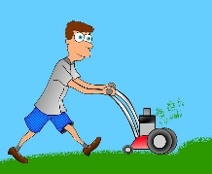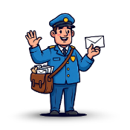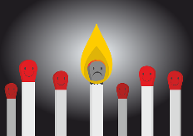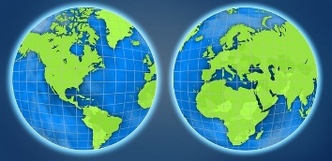
34 Mower - You can mow anything.

35 Mail - Postman or letters. Postman Pat.

36 Match - Light up with it, set the fire going with it. Sporting event.
37 Mug - Fill the mug with liquid, drink from it, and put things in it.

38 Movie - Movie camera, make a film with it.

39 Map - Make it a huge map that can be unrolled and rolled up again.

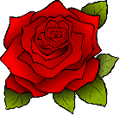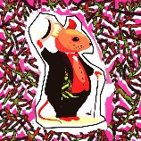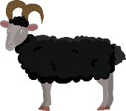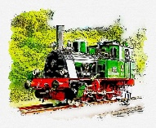

40 Rose - Smell the rose, touch it, or prick your finger on it.

41 Rat - Make your image quite different from the mouse (30) I now use Fred Astaire in Top Hat. Thought process Rat/ Froggie went a courting - Uncle Rat/ Dapper Man/Fred Aistaire dancing. I find Fred a strong image for 41, but note my thought process – how I got from Rat to an image of Fred Aistaire.

42Rain - The look of rain, the sound of rain, things getting wet.

43 Ram - Always butting something. Song -‘High Hopes’.

44 Rower - Put people into the rowing boat. Row the boat across unlikely places.

45 Rail - All things to do with trains and railways.

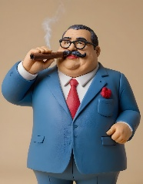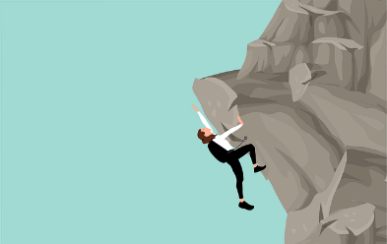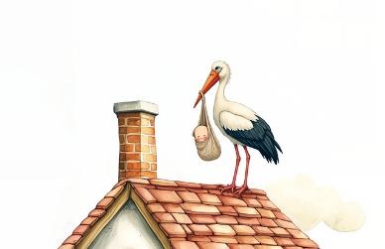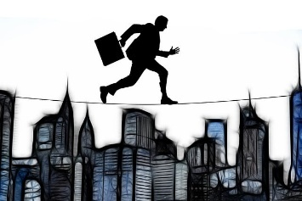

46 Rash/Rich - I cover something in spots. Otherwise, an image that represents someone rich, maybe the guy in the Top Hat from Monopoly.

47 Rock - Make it big or small. Climb on it or throw It. Or choose a rock band.

48 Roof - Climb on the roof. Sit on it.

49 Rope - Tie things up with it. Stretch it between objects.
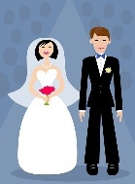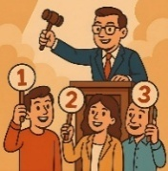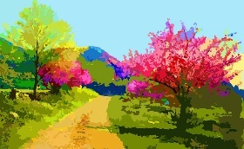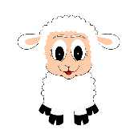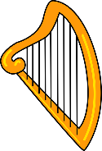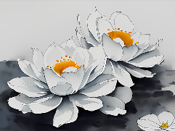

50 Lace - Quite often, I choose a bride.

51 Lot - Parking Lot or an Auction Room.
52 Lane - The lane can lead somewhere. People walk down it.

53 Lamb - Lambs in the spring. Add sound and movement.

54 Lyre/Lure - Small harp. Egyptians used them. A trap for something or someone.

55 Lily – Water lily or Arum lily or lily of the valley. Smell them.

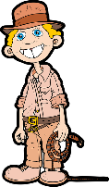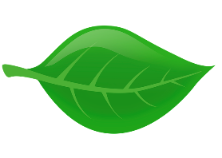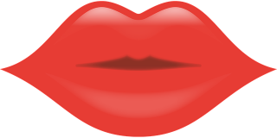

56 Lash - Whip. I use an image of Indiana Jones. Please note that my images are optimistic. Don’t introduce bad stuff into your imagination.

57 Lake – Peaceful

58 Leaf – Falling leaves and images of the Fall. Cover things with leaves. Fresh spring leaves.

59 Lip - Big and red. Kissing.

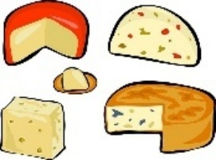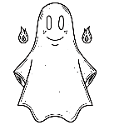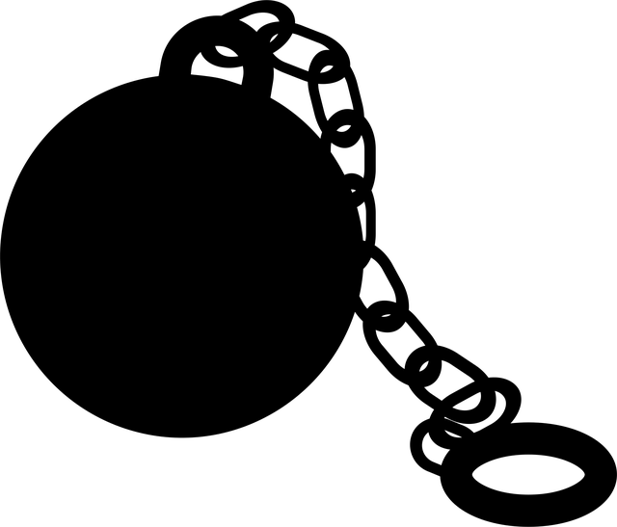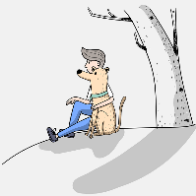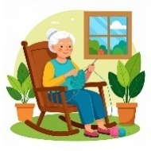

60 Cheese - I use a big red cheese from Holland.

61 Sheet - Use it to cover up things. Dress people in it.

62 Chain - Chaining something up. Ball and chain.
63 Chum - Your best friend, I use an image of a friend of 70 years, very powerful, and she is always 16. Otherwise, Dog Food not a dog as you could mix it up with 17.
64 Chair - Perhaps a rocking chair to add movement.

65 Chill - Someone shivering - wrap them up. Chilly weather/snow.

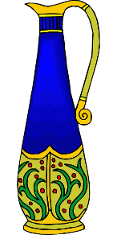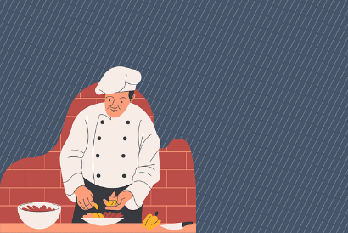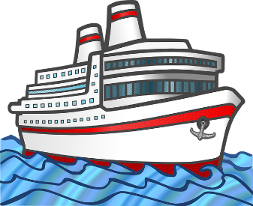
66 Cha-cha - Any couple dancing. Any dancing
67 Cheque/Jug - Exaggerate with a great big lottery-type cheque. Otherwise use the 'j' sound for 6 which gives jug, which is a particularly useful image.
68 Chef - Maybe use one of the T.V. celebrity chefs.
69 Ship
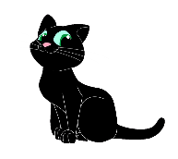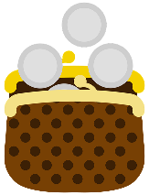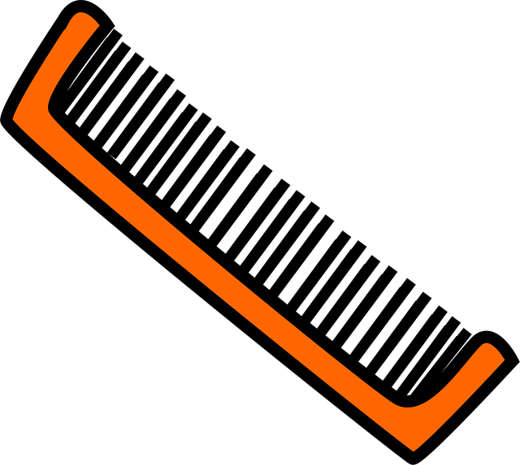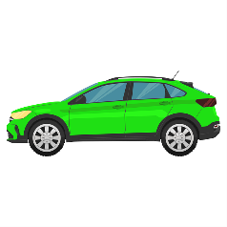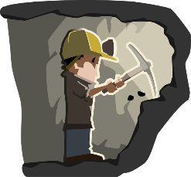

70 Case - Especially useful for putting things in or taking them out.

71 Cat - Maybe a favourite cartoon cat.

72 Coin - A single coin. Toss it in the air. Put it in a slot machine. Do not mix it up with 76 CASH.

73 Comb - Exaggerate the size.

74 Car - Make your car quite different from your cab. Perhaps a vintage car or a racing car.

75 Coal - Pour the coal out in huge heaps. Throw it. Make it all very dirty.

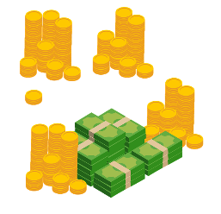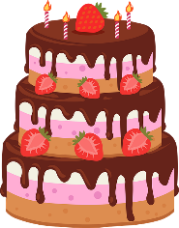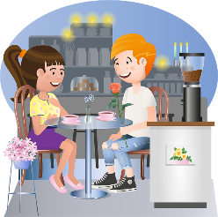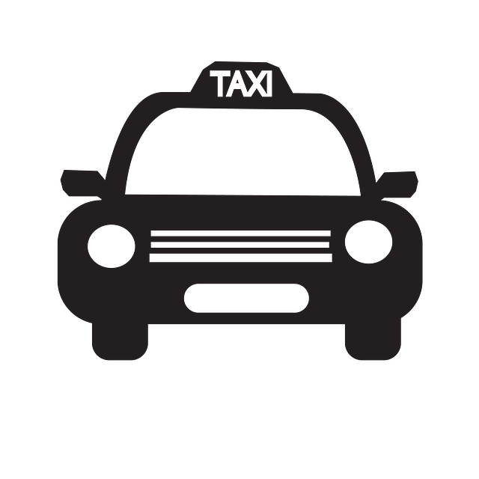
76 Cash - Not to be confused with coin. Make it a lot of cash. A jackpot at the casino.
77 Cake - As big, gooey, and creamy as you can imagine.
78 Café - An especially useful place for meeting people.
- Cap/Cab - Strong images, especially a cab - put people and things in it, and go somewhere.
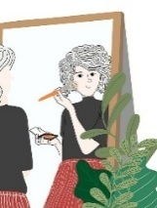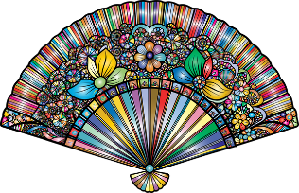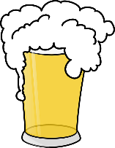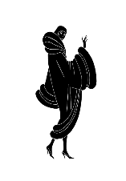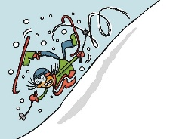
- Face – Another image I found difficult, but I settled on Looking in a mirror, which works for me.
- Fat - Very, very Monty Python fat. I use Sir John Falstaff
- Fan – wave it, Spanish senorita, Egyptian slave, Victorian lady
- Foam/Fame - Lots of foam, or pick a celebrity or film star.
- Fur - Cover things with fur or put people in fur coats
- Fall - Add movement and sound.
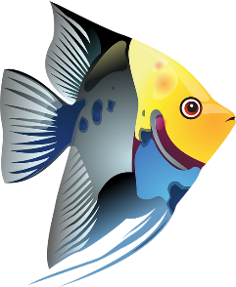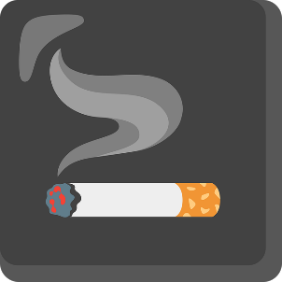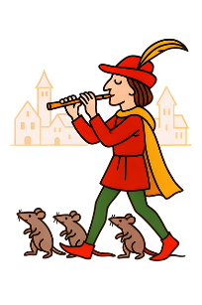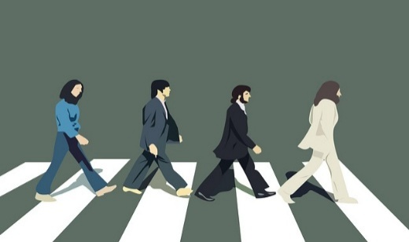

- Fish - Eat it or swim with it.
- Fog or Fag - I find the image of a fag much stronger than fog. Light a fag, stub it out. Fog, for me, says Sherlock Holmes.
- Fife - Flute-like instrument. Play it. Maybe an image of the Pied Piper.
- Fab/Fop/Fob – I always use the Fab Four

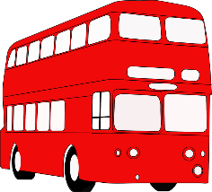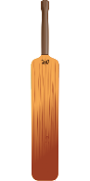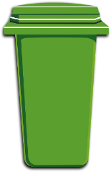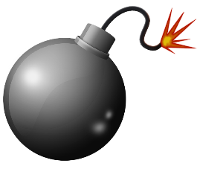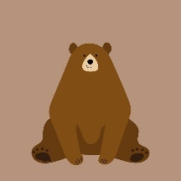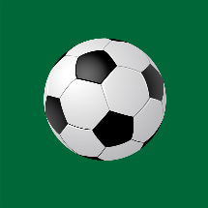

90 Bus

91 Bat

92 Bin

93 Bomb

94 Bear – Fozzie, Yogi, Paddington

95 Ball

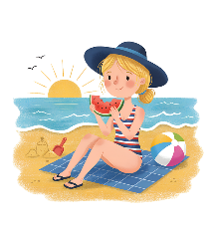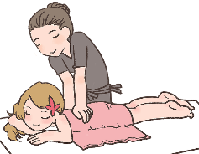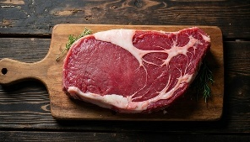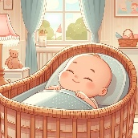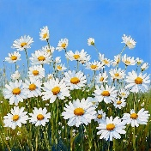

96 Beach - A student suggested Posh Spice, which is a good example of following the rules P-sh (9-6).

97 Back - I thought the image of a massage would be helpful than the more obvious back

98 Beef – roast beef, steak sandwich

99 Baby/Pipe/Pope - Use a baby in arms, not to be confused with a tot. Smoke the pipe. Think Magritte.

100 Daisies - D S S a double 00. Lots and lots of daisies in the grass.

So with those 100 images, you will be able to put together dates and long numbers and always remember what good exercise this is for your brain.
Congratulations on completing the Major System. Good luck and do the practice.
In the next series, you can discover all the fun things you do with the 5 mnemonic tools you have now mastered, including learning a pack of cards that really will amaze your friends, but is actually quite easy.

