06 The 10 Largest Countries in the World
This document is to accompany my podcast called Remember Word4Word, and in this episode, you will learn the 10 Largest Countries in the World. This uses the 5th and last of the basic mnemonic techniques and how to apply it. It is also the last of the 3 numerical systems, and it is important because it takes numbering up from 0 to 100 and beyond, which is invaluable if you want to memorise long numbers - card and bank numbers, dates, prime numbers, pi, and the periodic table, etc.
The countries are not nearly as difficult as the mountains, and so you can concentrate on the images for the numbers 1 to 10 using the Major System.
To recap, numbering is a form of loci. It will give your mind an image for a number which you will conjure up when you want to recall a listed piece of information.
Please do not fall at this fence. If a child of 5 can learn 52 symbols representing the sounds of the alphabet, all I am asking is that you learn a measly 10 sounds and images to accompany those sounds to represent the numbers 0 – 9. If you become desperate, go out and find a child of 5 to help you. Apologies to Groucho Marx, but if you think about it, that is what that child has to do: translate the word he knows into strange written symbols. I well remember the first word I ever read. I was with my mum and saw a billboard with OXO written on it in huge letters, and I read out loud, Oxo, and I still remember my delight in this achievement.
I must confess that I have never taught the Major System before lunch. I always needed at least one glass of wine because I knew I was going to have to persuade my students that this exercise was really, really important, but I also knew that initially, they were going to find it a bit complicated. So far, they were delighted with the ease with which they used the previous techniques and were hungry for more. The Major System IS more, but it needs a little bit more work.
The system is based on consonants and the sounds they make if you leave out the vowel sounds. If you take the consonants B-D and add a vowel in the centre, you get the words:
BaD, BeD, BiD, BoD, BuD – all of which you can represent with an image.
Using this system, you can come up with images which will take you from 0 - 100 pegs. After that, if you need it, you can take the principle into the thousands. You can literally learn anything you want; nothing will be too big, and you will have all the pegs you need.
The consonants are reduced to 10 sets of sounds, corresponding to the numbers 0 - 9. As 0 - 9 can represent all the numbers that can be counted, so can the words made by these sounds represent all numbers too. Remember, we are talking about the sounds that letters represent, not the letters.

The Major System 0 – 9. These are the 10 images and sounds to be associated with 10 sets of consonants, and they DO have to be learned. There is no shape or rhyme to help you out, but I did create a silly story that seems to work, and one of my students supplied an excellent acronym which you might prefer to my idiotic story. I will also add pictures to my document, which may help you too, but even better, draw some for yourself.
Note that hard c and soft c are assigned different numbers because the same letters have different sounds.
0 = s, z, soft c
0 = is represented by the soft 's' sound or 'z' sound and the soft 'c' as in ceiling.
It is represented by the image ZOO and SAW because if you take away the vowel sounds all that is left is a z and an s. You can remember that the sound 'z' represents 0 because zerO ends in O.
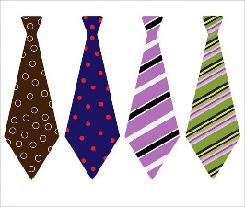
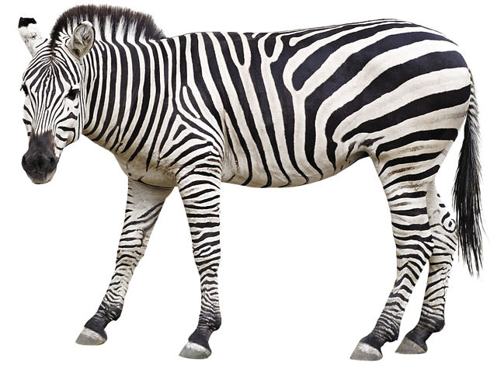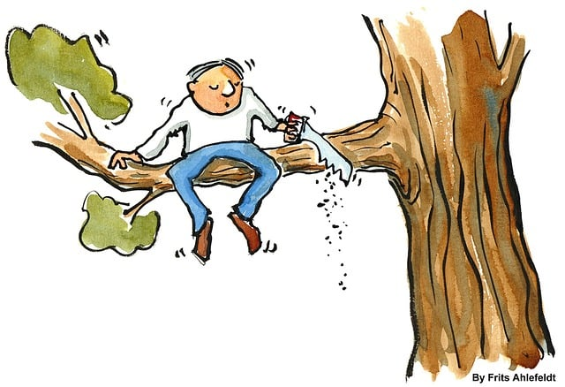
1 = d, t

1 is represented by a ’t’ or ’ d ’ sound, and the image is of a tie. If you ignore the vowel sound, the word 'Tie' has no other consonant and therefore no other sound apart from ’t’. These rules would also allow you to use the word ‘day', but this is not such a strong image as Tie, although if you are old enough, you might remember the newscaster Robin Day, who was renowned for his extravagant bow ties.
So the image for 1 is a tie, and another help is that both ‘d ' or 't ' have a single down stroke.
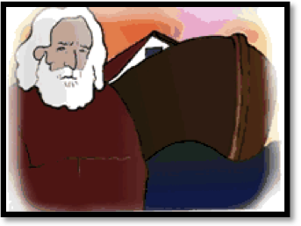
2 = n
2 is represented by an 'n' sound, and the image is of Noah. If you ignore the vowel sound, the word 'Noah' has no other sounding consonant and therefore no other sound apart from ‘n’.
So, the image for 2 is Noah.
You can remember that the sound 'n' represents 2 because n has 2 down strokes.
3 = m

3 is represented by a 'm' sound, and the image is of Ma. Ignore the vowel sound, and the word 'Ma' has no other consonant and therefore no other sound apart from ‘m ’.
So, the image for 3 is ma.

You can remember that the sound 'm' represents 3 because m has 3 down strokes, or you might like to use the acronym 3MS.
4 = r
4 is represented by a 'r' sound, and the image is of Rye. If you ignore the vowel sound, the word 'Rye' has no other sounding consonant and therefore no other sound apart from ’r'.
The image of rye, either the grain as in rye bread or rye whisky, will represent 4. You can remember that the sound ‘r' represents 4 by remembering that fouR ends with an R. Personally, I like to use the image of rye whisky, and whenever I have a drunk wandering through my stories, I know that I need the number 4. Sound is good for the imagination, too, and you might like to listen to Ted Ritter with the lyrics
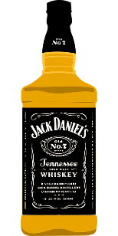
And it's a whiskey, rye whiskey
Whiskey I cry
If I don't get rye whiskey, well, I think I will die
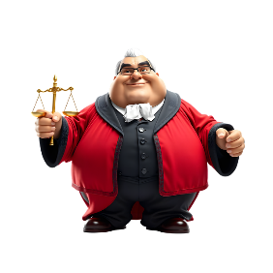
And play that in your head when remembering 4 rye

5 = l

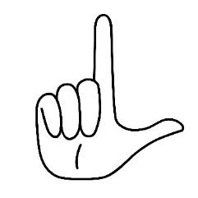
5 is represented by an 'l' sound, and the image is of Law. If you ignore the vowel sound, the word 'Law' has no other sounding consonant and therefore no other sound apart from ’l'.
I use an image of a judge holding scales, which may be a useful alternative image. The image of the Law represents the number 5. You can remember that 'l' represents the Latin for 50 or that the L hand gesture is for Loser
6 = 'ch', 'sh', and 'j
6 is represented by the soft sounds of 'ch' as in church, 'sh' as in shoe, and 'j' as in 'jug' and the image is of a shoe. If you ignore the vowels, the word 'shoe' has no other sound apart from ’sh'. 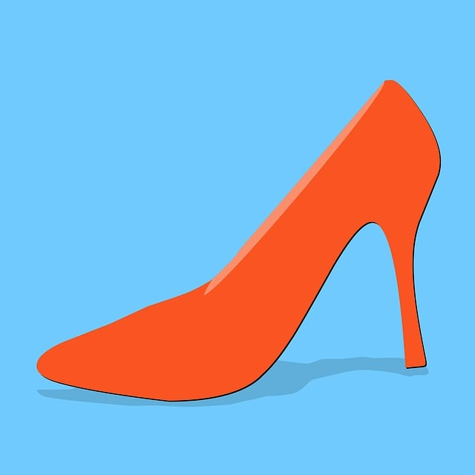

The image of a shoe represents 6. Make sure that this image is quite different from the one you used for 2 in the rhyming technique, think high stilettos in 'The Devil Wears Prada'.
7 = ‘c’, ‘k’ ‘g’
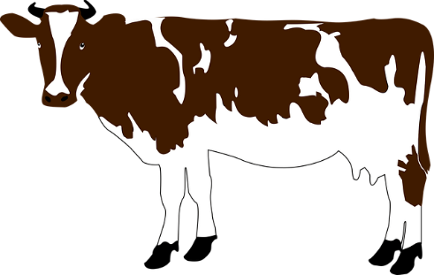
7 is represented by the hard 'c' a k and a hard 'g' as in goat. The image is of a cow , as if you ignore the vowel and non-sounding consonant, there is no other sound apart from ‘c’.
The image of a cow represents 7
8 = v, f

8 is represented by 'v' and 'f'. The image is of ivy , as if you ignore the vowel and non-sounding consonant, there is no other sound apart from ‘v’.
The image of ivy represents 8
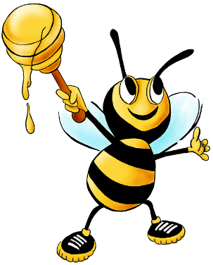
9 = b, p
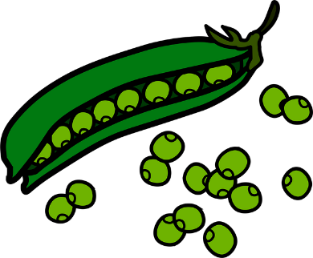
9 is represented by 'b' and 'p'. The image is of a bee or you could use a pea. If you ignore the vowels, there is no other sound apart from 'b' and 'p'.

It is most important that you learn these ten sounds and their accompanying images.
I should like to thank an actor participant of a workshop who came up with the following witty mnemonic to help remember the letters:
So Did Noah Make Rough Layouts Showing Complex Vision of the Boat
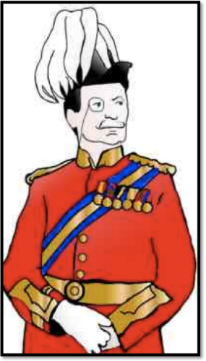
Learning the Major System requires a little effort, but it is well worth it. It is also a good exercise in using that other powerful memory tool - LINKING.
To remind you, Linking is creating a story to link together things you want to remember.
There follows a very silly story which will link the 10 sounds of the Major System plus the Rhyming System to help - but REMEMBER - the rhyming system is just there as an 'aide memoire' (literally ‘memory aid'), it has nothing to do with the Major System.
For the numbers 0 to 9, we begin with the rhyming system. This is just to help you learn the story and to identify the number to which we are going to attach the sounds. Let me introduce:

MAJOR SYSTEM
One night, the Major went to his club as usual and imbibed enormous quantities of brandy. Getting home, he decided to dress up as his alter ego, the Roman emperor NERO (ZERO - 0).
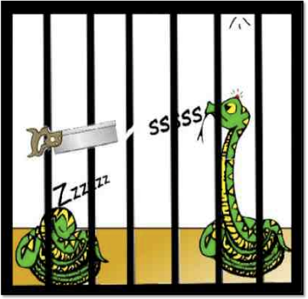
With some muddled idea about the Colosseum and animals, he made his way to the ZOO where he began to SAW his way into a cage. There was a snake asleep in the cage, making a zzzzzing sleeping sound. However, the sound of the saw woke it up so suddenly that it jumped and hit its head upon the Ceiling. This made it hiss angrily ssss.

O ZOO, SAW z, s,c
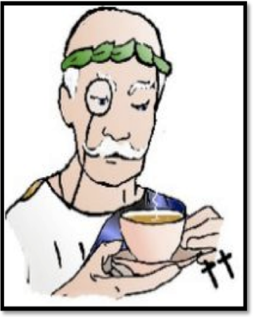
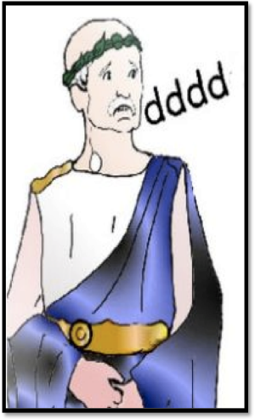
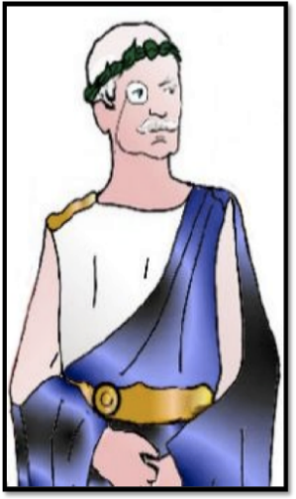
The General, hearing the hiss, was so terrified that his teeth began to chatter “dddddddddd".

1 d t
To settle his nerves, he took out his trusty vacuum flask and poured himself a nice, reviving cup of tea, although the cup still rattled in the saucer a little, "ttttttt".
Feeling braver, he offered the snake a bun (One 1, please do not be confused by this. It is the rhyming system, and I have only put it in to help you remember the first 10 digits of the MAJOR SYSTEM).
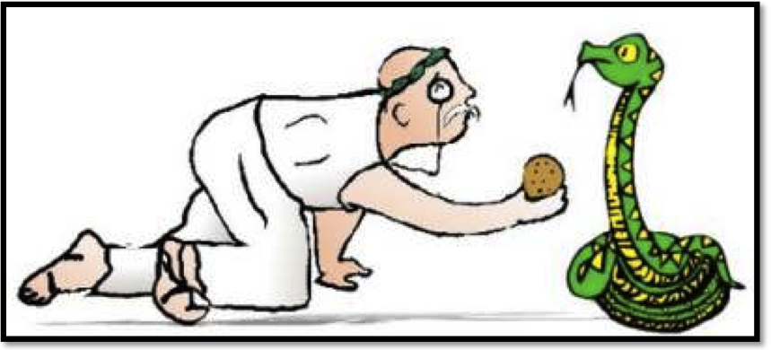 The snake was so pleased with the bun that it wrapped itself around him like a wonderful green and yellow TIE.
1 TIE
d, t
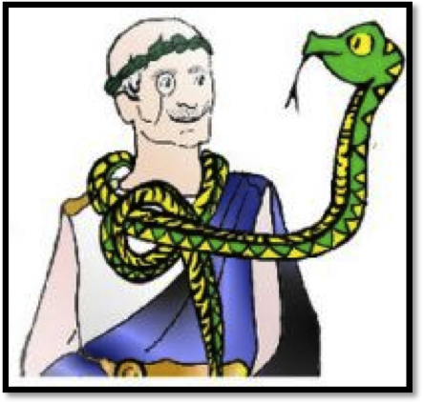
The image for 1 is Tie. It represents the sounds "t" or "d".
Let’s recap: 0 is represented by the sounds z, s, and c as in ceiling and the image is a zoo or a saw because neither word has any vowel sounds. 1 is represented by a d or a t and is represented by a tie because it has no vowel sound.
The snake confided that he had been very lonely, stuck in a cage by himself. What he really wanted was to join all the other animals in the ark.
The Major said he would take him to the ark, so he changed his sandals for SHOES (2 RHYMING), and they set off for Noah's ark.
When they found NOAH, he shook his head sadly at their request. The snake had got such a bad reputation over the Garden of Eden fiasco that he would have to say "No".

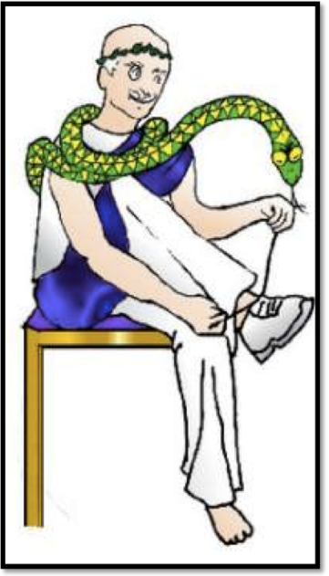
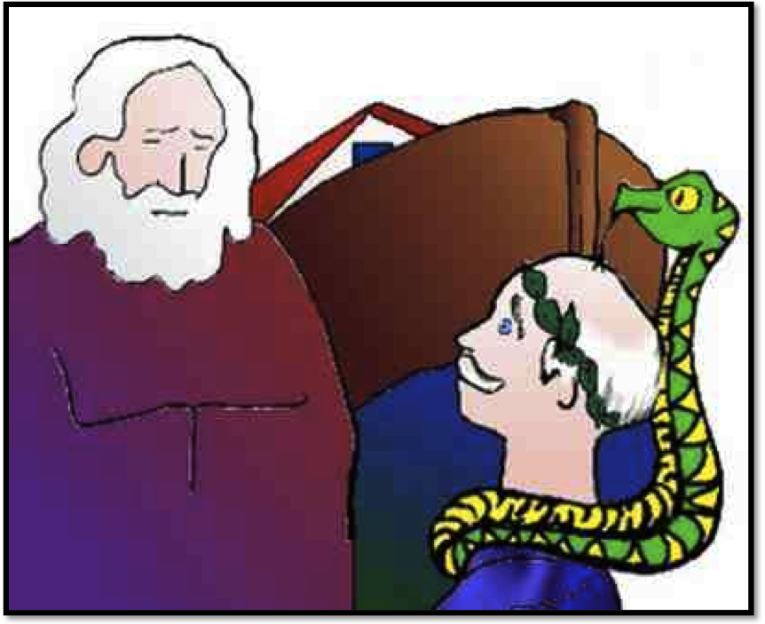
2 NOAH
n
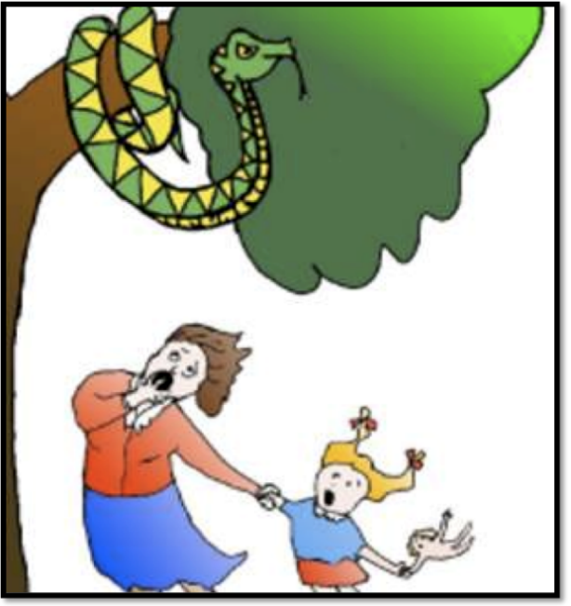
The image for 2 is NOAH. It represents the sounds "n"
The snake was philosophical. "I'll just wrap myself around this TREE (rhyming 3) until the flood subsides", he said. Note that we have now dropped both the General and Noah from the story. In this kind of idiotic tale, we do not need a character arc.
Unfortunately, he still did not understand how scary he was, and when a mother and child walked by, they were terrified and ran away. The child was crying "MA" and her little doll was repeating the phrase "ma ma".
3 MA
m
The image for 3 is MA. It represents the sound "m".
Ma ran away as fast as she could, dragging her little girl with her.
When she got home, she slammed the DOOR (rhyming 4) behind her, thankfully.
She cut some RYE bread for her daughter's tea, and then, pouring a large glass of RYE whisky out for herself, she collapsed on the floor.
4 RYE
r
The image for 4 is RYE. It represents the sounds "r".
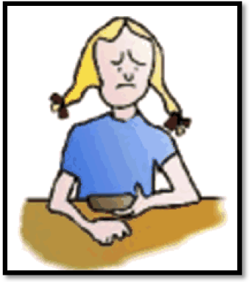
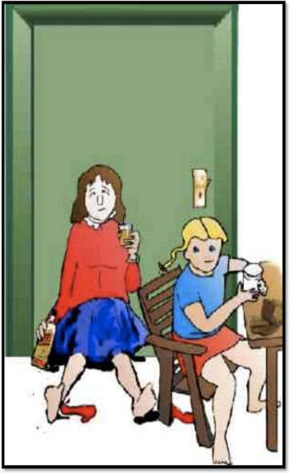
Unfortunately, her daughter was not at all happy about having plain bread for tea. She wanted honey on it.
Her mother was desperate: they had no honey. She was also not sober, so she decided to creep next door and steal some honey from her neighbour's HIVE (5).

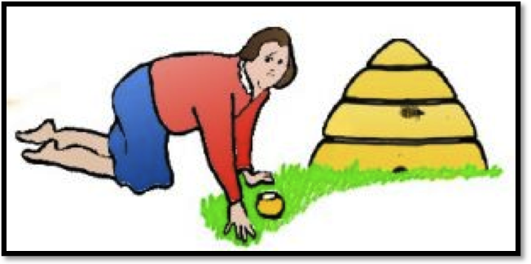
Sadly, she got caught and ended up in a court of LAW charged with trespass and theft.
5 LAW
l
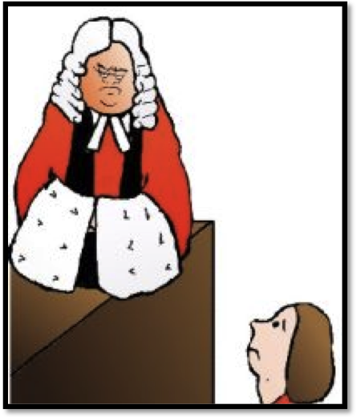
The image for 5 is LAW. It represents the sound "l".
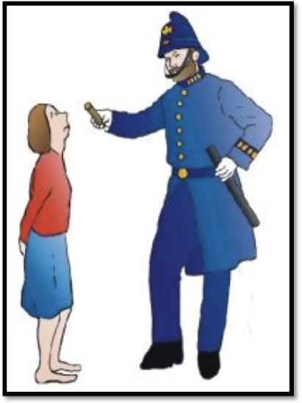
The judge let her go, and the policeman who arrested her, shook his STICK at her as a warning (rhyming 6).
Then he gave her back her SHOES, which she had taken off in the garden as they were quite unsuitable for trespass and burglary, and she was allowed to go home.
6 SHOE sh, ch, j
The image for 6 is a shoe. It represents the sound "sh" as in shoe, the soft "ch" as in cheese, and a soft "j" as in 'judge'.

Ma was so relieved that she skipped home, taking a shortcut through a meadow filled with cows. She did not notice the huge bull that was there, too. Unfortunately, he noticed her.
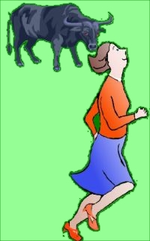
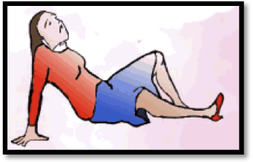 The next thing she knew, there was a crashing bump, and she woke up to find herself in cow HEAVEN (rhyming).
To recap: 0 z,s, c, image zoo, saw, 1 d, t, image tie 2 n image Noah, 3 m image ma, 4 r image rye, 5 l image law, 6 sh, ch, j, image shoe, 7 c, k, g, image cow

"What am I doing here?" gasped Ma. "Well, I imagine you met Bernie, our bull", said a nearby cow, casually plucking a harp.
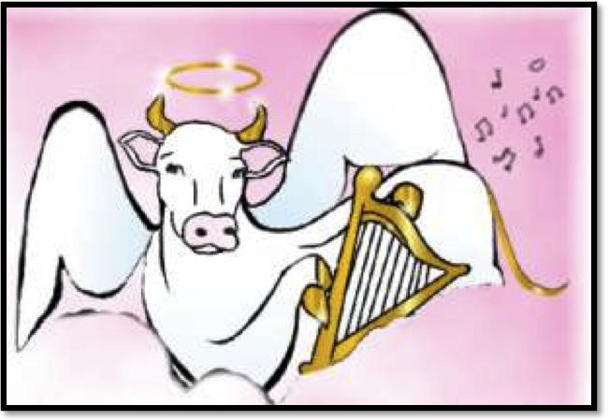
7 COW
hard c, k, g
The image for 7 is COW. It represents the sounds "c" as in cow.
"I don't want to stay here", said Ma. "Suit yourself," said the cow, a bit huffily, "follow that IVY path to the golden GATE. Find your own way from there."
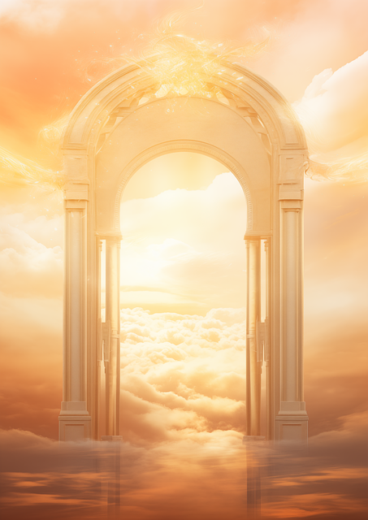

8 IVY
f, v
The image for 8 is IVY. It represents the sounds "v" as in IVY or "f" as in FISH
At the gate, there was a long, rainbow-coloured clothes line looped around it. The end fell straight through the clouds and down to earth. Ma grasped it firmly and slid down - straight into her own kitchen.
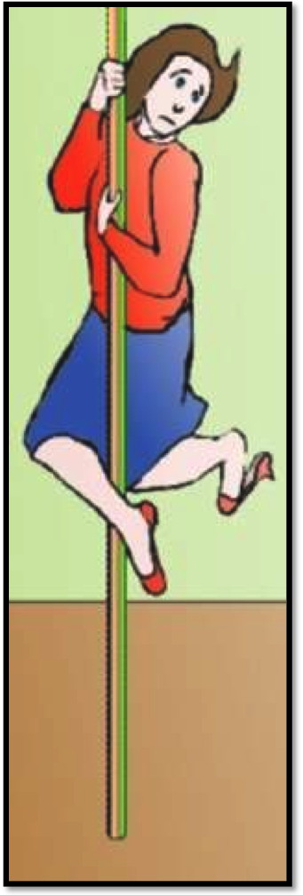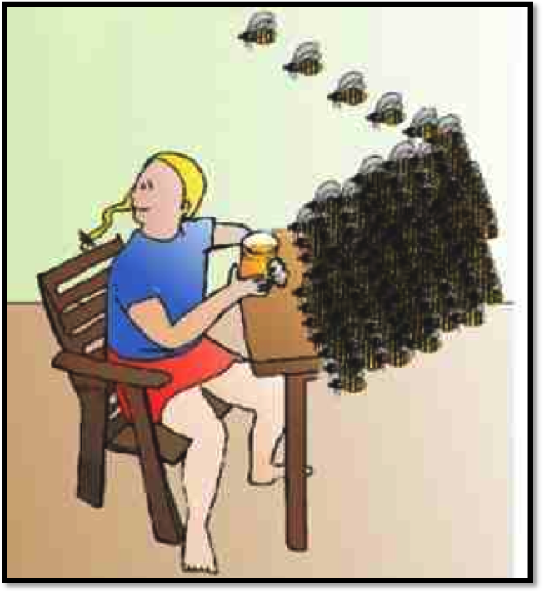 Her little girl was still at the table. "Hello, ma", she said brightly. "Don't worry about the honey - I have all that I need. Look where next door's hive has swarmed to!"
9 BEE
b, p
The image for 9 is BEE. It represents the sounds "b" as in bee or "p" as in pea.
Final recap: 0 z,s, c, image zoo, saw, 1 d, t, image tie 2 n image Noah, 3 m image ma, 4 r image rye, 5 l image law, 6 sh, ch, j, image shoe, 7 c, k, g, image cow, 8 v, f, image ivy, 9 p, b, image bee or pea.
THAT'S IT! That really is the worst you must learn. Taking these 10 digits up to 99 is easy, and beyond that, to as many thousands as you wish is equally easy. But for now, spend a few moments going through that silly story, or if you prefer the anagram So Did Noah Make Rough Layouts Showing Complex Vision of the Boat or both, to check you have the correct images for numbers 0-9.
10 is a double figure, and all you need to do is add the sound for 1 – t and add it to the sound for zero ‘s’, remember that in the Major System we leave out the vowels, so the image for 10 is TOES -T S(1=T, 0=S). We will cover the principle for double figures more thoroughly in the next podcast, so if you are stuck, don’t worry, just use the rhyming image ‘hen’ or the shape image ‘bat and ball’ for number 10.
10 largest countries
1.  Russia
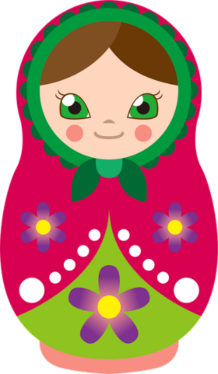

Just as you did with the mountains, take a stereotype image that you have for Russia.
Realise that there is no right or wrong image - only one that works for you and gives you the correct answer. You may have several and use whatever fits best with your story. Have fun! Here you need to match your image with a tie (1 in the Major System) so give your Russian dolls bow ties or if you chose a man in a furry Ushanka tie a bright tie round it.
2.  Canada
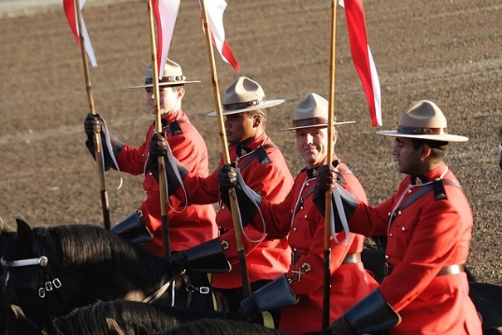Have your Mounties ride up onto Noah’s ark.
3.  United States
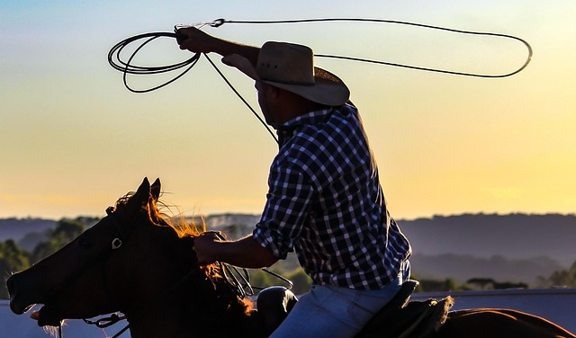
You may want to use the cowboy motif again, as we did with the rivers, and so have MA being lassoed by a cowboy. China is next, and you might want to put the images for these countries into your glossary so that anytime you need to remember Russia, the USA or China, you will already have a strong image for those countries.
4.  China
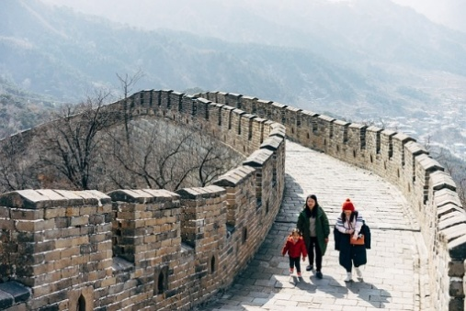
Tie the image in with rye. You could use the image of the wall, which we used for rivers, and people could be having a picnic with rye bread, but it might be quite fun to have a Chinese dragon where all the carriers get drunk with rye whisky and are falling about all over the place. Remember, humour and action really help you remember.

5.  | Brazil
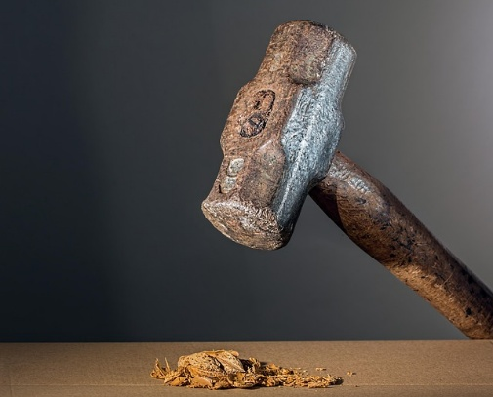

5 is the law, so imagine a judge crushing nuts with his gavel. Of course, English judges do not have gavels, but we have all seen enough American films to imagine it.

6.  | Australia
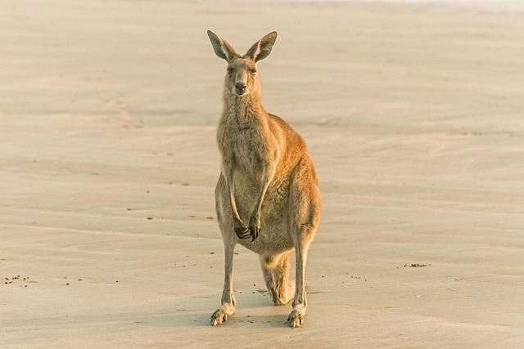
6 is a shoe, and so put some red high-heeled shoes on your kangaroo, or you could put them on Crocodile Dundee too.

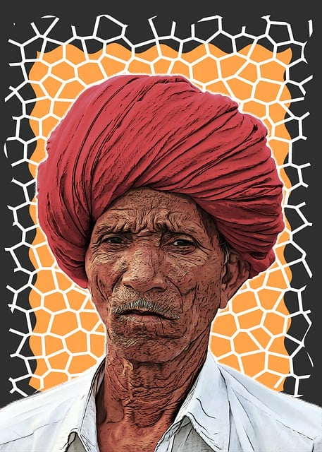
7. India
7 is cow, and that makes it rather easy, as for much of India, the cow is sacred.

8. Argentina
If you are Jilly Cooper or me, you will think of polo when you think of Argentina.
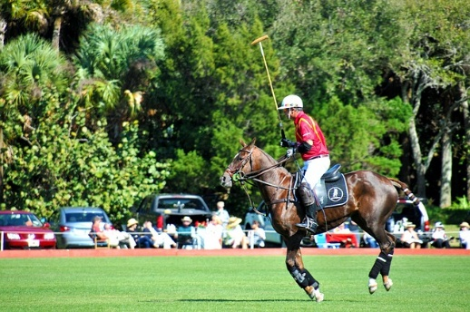
The image for 8 is ivy, and so your polo players could be battling in a pitch overgrown with ivy,
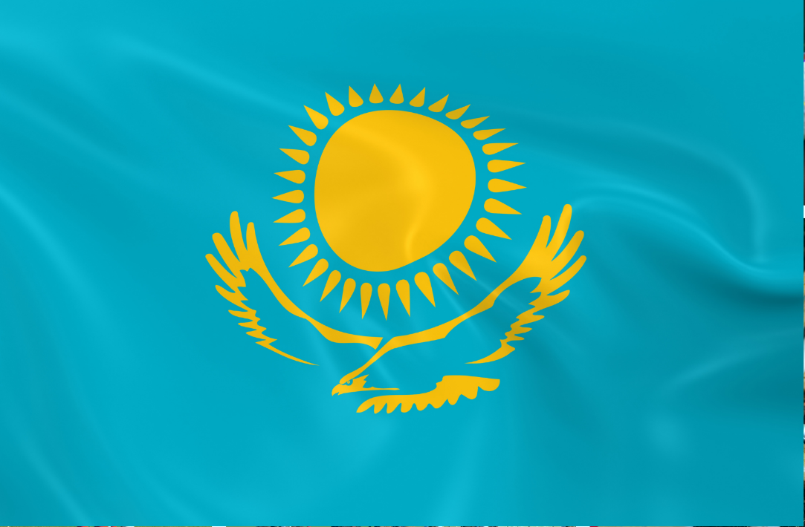
Or maybe you prefer to visualise those horses galloping over the pampas or Eva Peron on the balcony - again festooned with ivy.
9. | Kazakhstan
The image for 9 is a bee or a pea. I am afraid that for me the country of Kazakhstan is linked forever with Borat: Cultural Learnings of America for Make Benefit Glorious Nation of Kazakhstan, and it is not difficult to add a scene to his documentary involving either bees or peas.
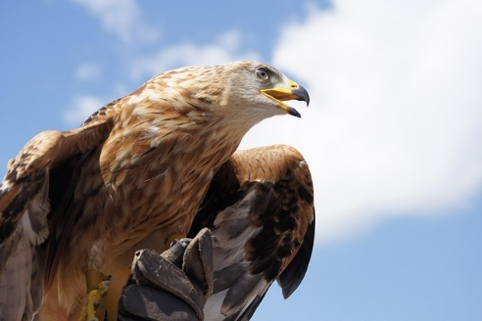
If Borat means nothing to you, and you have difficulty remembering the country, then break up the word - CAR ZACK (if you don't know a Zac, then use a film star (Zac Efron - High School Musical, Zac Braff - Scrubs) STAN (if you don't know a Stan then use a film star, Stanley Laurel, Stanley Holloway or a Stanley Knife. You could also tie in the beautiful design on the flag of the golden steppe eagle underneath the golden sun against an azure blue sky.
10 Algeria
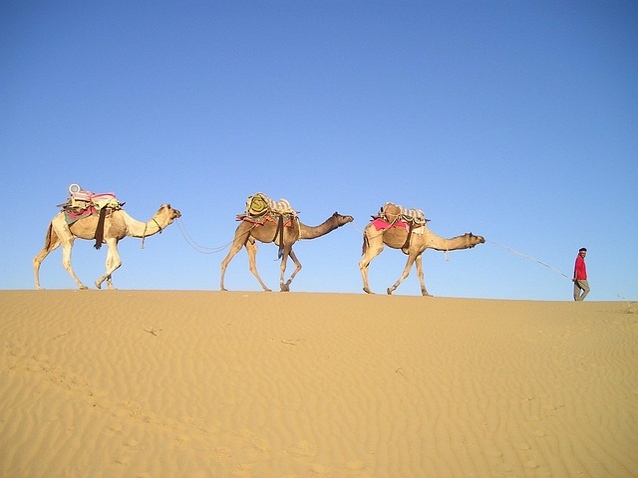
To recap, you have not learned 10 yet, but the image for 10 is TOES (1=T, 0=S).
So, you can imagine an Arab with open-toed sandals or perhaps paint the toenails of the camel,
or otherwise have a caravan of hens travelling across the Sahara in Algeria.

Well, that is it, the final technique. The most challenging, I agree, but oh so worth the effort. In the next podcast, we will translate those 10 images into 100 and beyond. In the meantime, practice these 10 until they become second nature. I find that when remembering numbers, I will chop and change with the 3 different systems – shape, rhyme, and major – choosing which image fits in most easily with what I want to remember, and I hope you will find the same. So Use it or Lose it.

