18 Word 4 Word What a piece of work is a man Part 2
I have of late, but wherefore I know not, lost all my mirth,
forgone all custom of exercises,
and, indeed, it goes so heavily with my disposition that this goodly frame, the Earth,
seems to me a sterile promontory;
this most excellent canopy, the air, look you, this brave o’erhanging firmament, this majestical roof, fretted with golden fire—
why, it appeareth nothing to me but a foul and pestilent congregation of vapors.

What a piece of work is a man,
how noble in reason,
how infinite in faculties,
in form and moving how express and admirable;
in action how like an angel,
in apprehension how like a god:
the beauty of the world,
the paragon of animals —
and yet, to me, what is this quintessence of dust?
Man delights not me, no, nor women neither
I trust you’ve now got the bare bones of this splendid speech firmly in your mind. It’s time to flesh it out with all the extra words and colouring. I shall prompt you with every one, of course, but I suspect you’ll find that many of them slip in quite effortlessly around the keywords you already know.
A quick reminder: we’re not learning this line-by-line like a parrot; we’re learning it thought-by-thought, complete with all the little flourishes that belong to each thought.
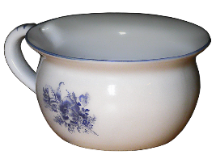
Some of my memory images may strike you as a touch eccentric (and if a better picture occurs to you that gives you the exact wording, by all means use it!). For instance, my own image for “I have” is a chamber pot with a large eye staring up from the bottom (there are lots of such images on the internet). Rather cheeky, I know, but the brain does adore anything a little bit naughty or absurd, and that’s what makes it stick!
Even if it is not a keyword, it is always a good idea to begin by focusing on the opening line of a speech.
I have of late, but
wherefore I know not,
lost all my mirth,
- I have – Eye lav - Hamlet sitting on the pot – silly image but memorable.
of late, - when you are trying to come up with an image for a word, relax, close your eyes, and see what your brain comes up with. You may well disagree with the images that pop up for me, and you probably will, as they are plucked from my imagination and experience, not yours, but I will describe how I got to them, which I hope will help you create your own pictures. Initially, I try out ‘sounds like’ as this is always very helpful in getting the right word. So late, gave me a plate. Then I had a picture of the white rabbit from Alice in Wonderland with his watch muttering, ‘I’m late, I’m late ’. The meaning of the word in this context is recent, but that does not help me; so I end up with the scene of Hamlet sitting on the ‘lav’ spinning plates, and if I need it, I will have the rabbit rushing by anxiously consulting a huge watch.
but
wherefore I know not,
But – he stubs out a cigarette in a water butt.
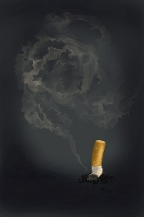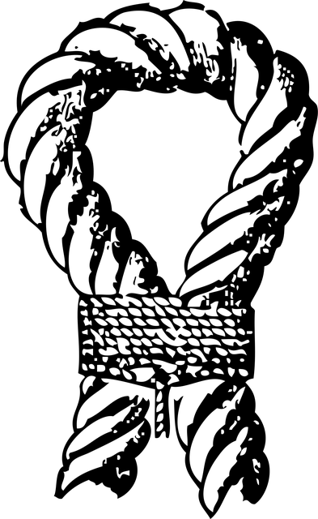
Wherefore I – for ‘where’ I use a werewolf. For ‘fore’ I always use a golfer shouting ‘fore’. These are very common words and you will find that you will often need images for them.
The werewolf hits a glass eyeball (I) which wizzes by Hamlet know not – for ‘know’ I use a sounds-like ‘snow’, so the eyeball buries itself in a bank of snow. For ‘not’ I would use a physical knot in a rope, but I doubt that you will need it here.
lost all my mirth,
You have already learned mirth as a keyword. If you need the rest of this phrase, think of the werewolf who has lost his eyeball in the snow.
The beginning of this speech is so well known that you probably won’t need this scene at all to set you off, but it is so daft, I doubt that you could forget it. It also has humour, naughtiness, action and sound - if you imagine plates crashing, the ssss of the cigarette butt in the water butt, and the whizz of the flying eyeball.
- forgone all custom of exercises,
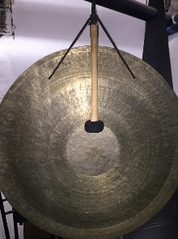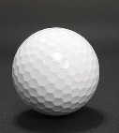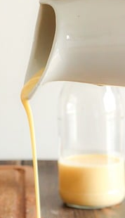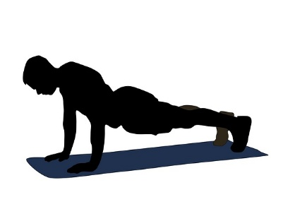
Scene 2 – Hamlet changes into golf shoes, shouts ‘Fore’ as he hits a gong. I use a golf ball for all which bounces off into a customs official who is exercising in custard.
You probably will get custom, but I have added in the custard just to help out and make the scene more ridiculous. Lots of action with that ball.
- and, indeed,
These are 2 of those wretched ‘filler’ words which have no strong image and yet will ‘glue’ a speech together. They are so common that all you need to do is create an image, and you will find yourself using it so often that they will no longer be a problem.
I use ‘ant’ for ‘and’. It is a sound-like and a strong image.
Indeed. For ‘In’ I always use a pub ‘Inn’ and so for ‘indeed’ I will put a lawyer in a pub with a Deed concerning a dead (sound-like) man - signing a deed on a coffin in a pub.
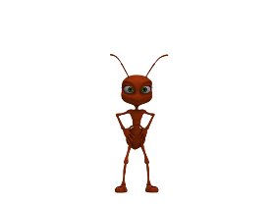 | 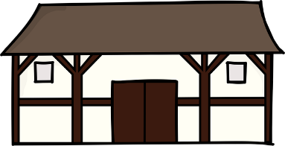 | 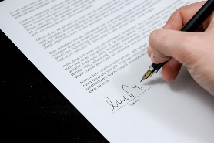 | 
Scene 3 – Hamlet follows a trail of ants into a pub where he signs a deed on top of a coffin.
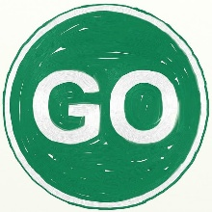
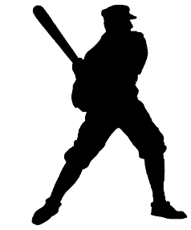
it goes
For it, I use ‘hit’. A sound-like which is a verb with action and sound. For go, I always use the ‘Go’ sign that road menders use so Hamlet hits the Go sign
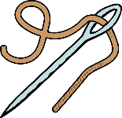so heavily
so is easy, just think of Julie Andrews singing ‘a needle pulling thread’.
heavily – It is the heavyweight Mohammed Ali sewing and you could throw in a snatch of the song ‘he ain't heavy, he’s my brother’.
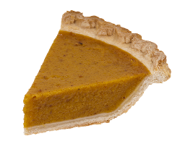
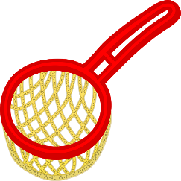
With my
I use a sieve a sound-like for with and a pie a sound-like for my so Ali takes a sieve and pushes a pie through it.
Now the keyword which you have already memorized.
Disposition
So leave the pub, find the tree with the discus player and throw a posy of flowers at him.
with my disposition
having described his mood Hamlet begins to list how it is affecting his outlook.
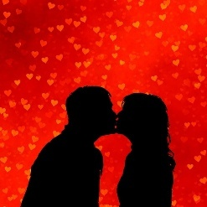
that this
More common words: I use ‘hat’ for that and ‘kiss’ for this.
Scene 4 Lift the hat to kiss a nun holding a wooden picture frame
 |  |  | goodly frame  the Earth,  Keyword against 4
Choose another image for Good if you like. I always use a nun, and so it works for me. but you might prefer to use the image of Hamlet kissing Barbara Good from the ‘Good Life’. It is a long time ago, but I know the series is often still repeated on TV.

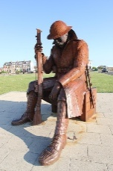
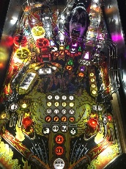

seems to me
– seam Tommy. ‘To me’ happens three times in this speech so decide on the image you want to use for ‘to me’. I use Tommy and hear Elton John or the Who singing Pin Ball Wizard. If that image doesn’t work for you, you could use Tommy, the slang word for a British soldier. It was first used by the Duke of Wellington, but is mostly associated with the soldiers of the 1st World War.
Picture the boat (4 shape system) on the sea with Tommy sewing a seam, or maybe put him on a steamboat.
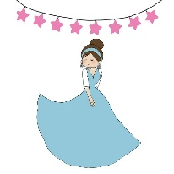
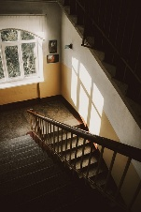
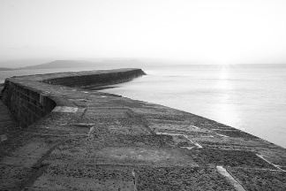
a sterile promontory - Sterilise a Stair Rail on the boat. Remember my comments about the keyword Promontory and my reference to the Cobb and famous stairs to the top.

glamorous frock, climbing up the mount or the Tor which is a hill or a rocky peak and add a Tory if you need to (use Maggie Thatcher)
Scene 5
this most
excellent canopy, the air, look you,

 |  |  |  | 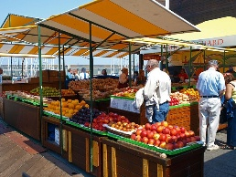 | 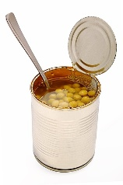 | 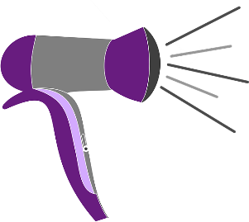
Kiss the postman or the lamp post. Take the eggs and sell them with a can of peas. Warm them up with a hair dryer.
Look at the ewe.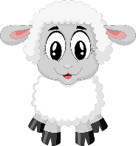

this brave o’erhanging firmament,

this | brave | 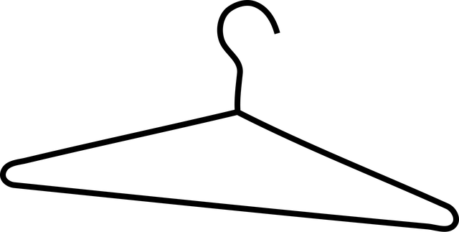o’erhanging | 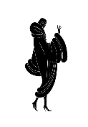fur | ma | mint

this majestical roof, - kiss Ma Jester/ Majesty/Coal/ on a roof.
this | 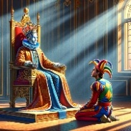  majestical | 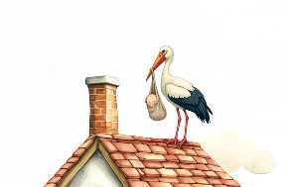  roof
fretted
with golden fire—

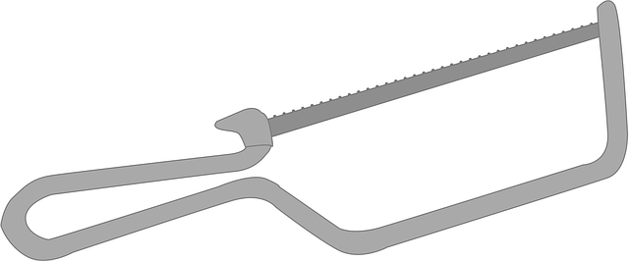fretted | 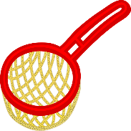  with |   golden |   fire

why, it appeareth nothing to me

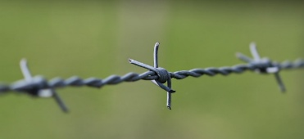  why | it | 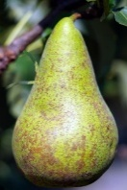    appeareth |     No thing | To me

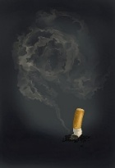  but a | 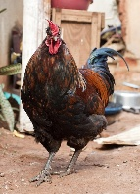  foul and | 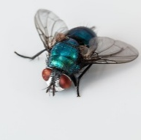  pestilent | 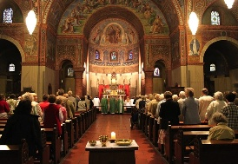  congregation of |   vapours

but a foul and pestilent congregation of vapors.

Hamlet describes his thoughts on mankind and begins his final list which I have started at 1
- What a piece of work is a man,
Man is the keyword, and the secondary words describing a man are a piece of work.

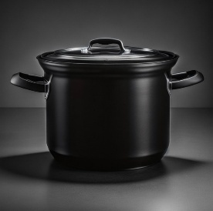 what a | 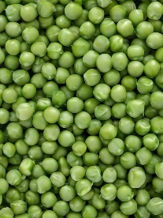 piece of | work | is a man

- What a piece of work is a man
I have used a man with a tie for ‘man’ as this is number 1 and Tie is 1 in the major system.
Pot of peas for what a piece
A road sign for men at work use the song too if you remember it

  how | 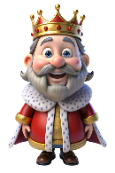 noble in | 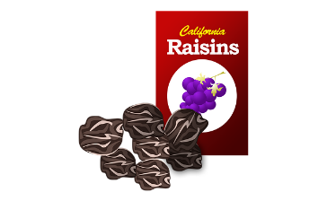  reason

- how noble in reason
I use a red Indian for ‘how’.
Noble works so well for number 2 on the list as 2 is Noah in the major system

 how | 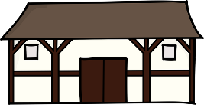 in |   fin | 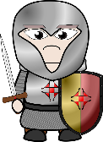  nite |   In faculties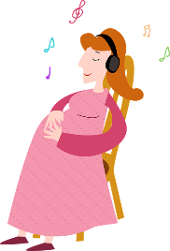

- how infinite in faculties,

Faculties is the keyword and the secondary word, describing them is infinite.
3 in the Shape system is Pregnant lady, in the Major system is Ma
Dorothy Parker said “Ducking for apples -- change one letter and it's the story of my life.”
And I am reminded of that quote with the word ‘faculties’. In which case, I think that a pregnant lady and ma both help one remember the word ‘faculties’.
"Faculty" has two main meanings: teachers at a university or college, or a natural ability.
‘Infinite’ and I think of Jaws swimming round an Inn in this case being fought off by a knight.

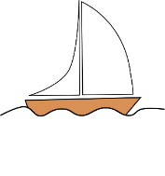 |  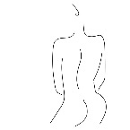in form |   and moving |   How express | 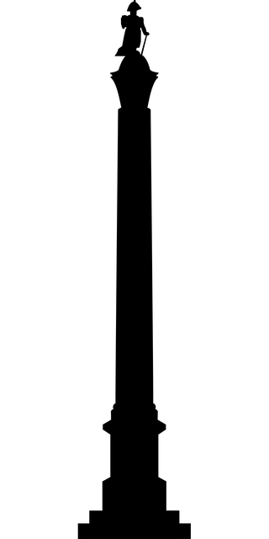and admirable

- in form and moving how express and admirable;
4 in the shape system is a sail boat which works well with a phrase to do with movement.
I have suggested 2 images for form, a document you fill in and a shape, which is the meaning for this phrase. Think of filling in a form for a moving van which then embarks on a boat which gets stuck on a railway line and is just pushed out of the way by Admiral Lord Nelson.
 |  in action | 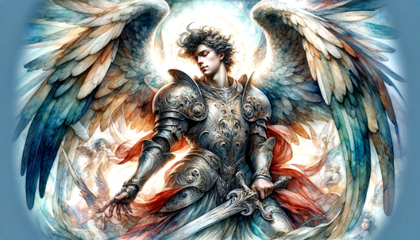  How like an angel
- in action how like an angel
The keyword angel and the word describing it is action
Ambrosia was the food of the gods and was often described as a form of honey, and so a hive would work well here, being suitable for a heavenly angel. Action gives me an image of action man and so he could be feeding the angel honey or vice versa.
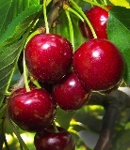 | 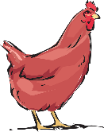  In ap pre hension | 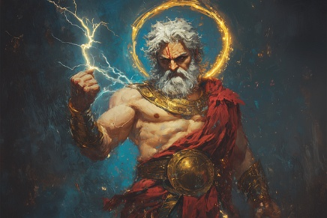  How like a god

- in apprehension how like a god
god is the keyword and the secondary word, describing it is apprehension.
6 in the Shape system is Cherry, 6 in the Rhyming system is Sticks, 6 in the Major system is Shoe
Apprehension gives me an image of an apple, a prep school child and a hen. If you need the -tion (shun) then make the child put down the hen as a guard of honour for the god. I have chosen Zeus as my god, as I use Zeus for other of my favourite images.

 |   The beauty | 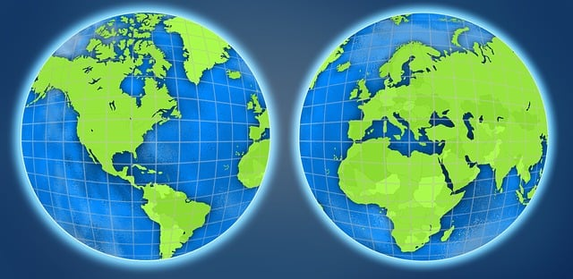  Of the world

- The beauty of the world,
World is the keyword, and the secondary word describing it is beauty.
7 in the Shape system is a Cliff, 7 in the Rhyming system is Heaven, 7 in the Major system is Cow
World and Heaven fit together and when I think of beauty, I see Sleeping Beauty, so either put her sleeping on a cliff or in heaven. If you can’t remember world, think of her eating a Curly Wurley before she falls asleep.

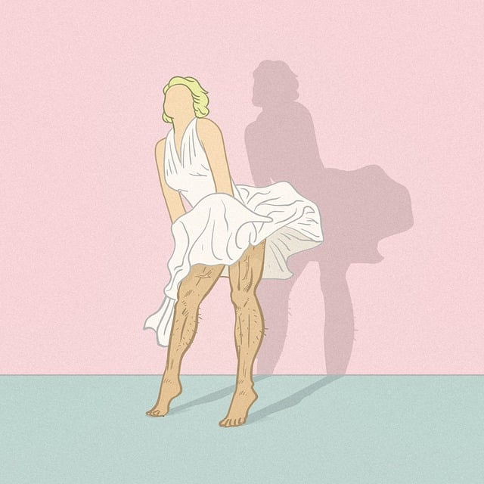 | 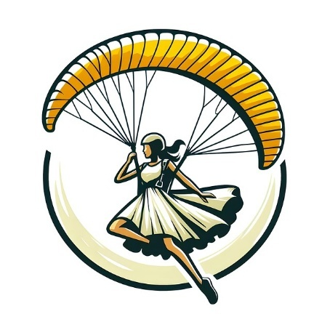  The paragon | 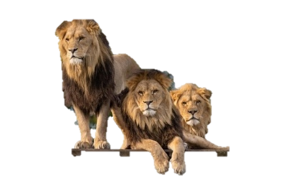  Of animals

- the paragon of animals
Animals is the keyword and the secondary word describing it is paragon.
8 in the Shape system is an Hourglass, Marilyn Monroe or a Snowman, 8 in the Rhyming system is Gate, 8 in the Major system is Ivy.
As paragon means ideal, model or nonpareil I think that Marilyn would be most suitable here for 8. Imagine her parachuting down into a zoo where there is a large variety of animals.

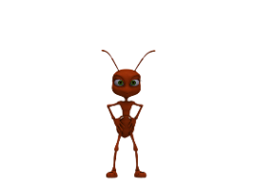and  yet  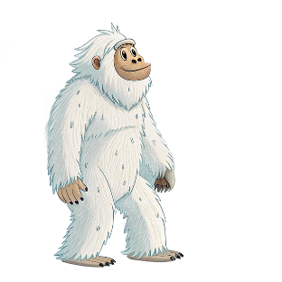  to me | 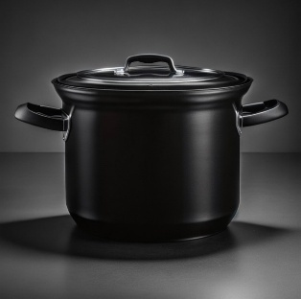  What    is  this | 2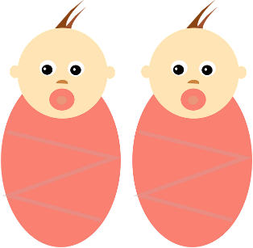  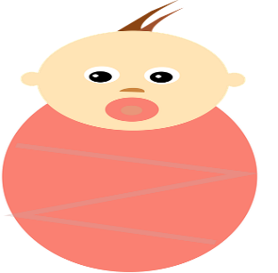    quintessence |   of dust

- —and yet, to me, what is this quintessence of dust?
9 in the Shape system is a balloon on a string, 9 in the Rhyming system is Line or Wine, 9 in the Major system is bee or pea.
You could picture a line of dust as this is the most powerful image in the whole speech.

Dust is the keyword and the secondary word, describing it is quintessence.
All the other words are the pesky little words that trip you up.
Silly but helpful images are:
ant for and,
yeti for yet,
tommy (soldier) for to me,
pot for what,
fizz champagne for is,
kiss for this and
quin + essence for quintessence.
Quintessence means essence. Picture a line of dust and quins holding balloons march on to it and begin spraying the dust with scent.

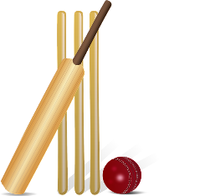 | Man | 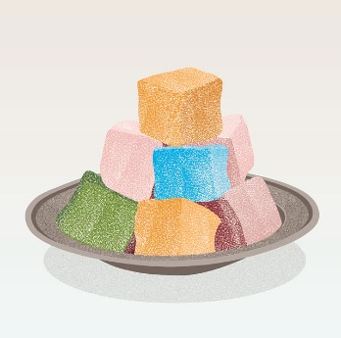  delights | 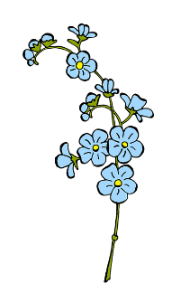  not me

no, nor  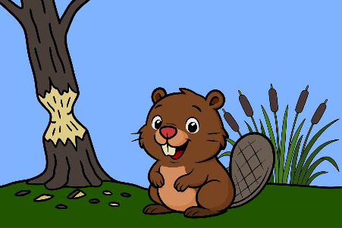 |   women | 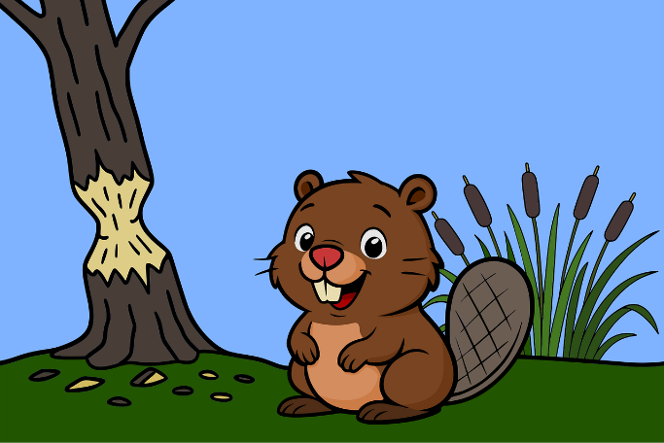neither

- Man delights not me, no, nor women neither;
- in the Shape system is Bat and Ball, Hen in the rhyming system, Toes in the Major system

Bat and Ball works well with Man so have him pause in the cricket match to enjoy some Turkish Delight while sitting by some forget-me-nots – a flower that conveniently contains the words not and me.
The final part of the phrase: no, snow, nor, (beaver) gnaws, women, neither sounds like beaver which fits in well with the phrase "nor women neither”

Hamlet ends this wonderful speech with the comment “though by your smiling you seem to say so.”

It would appear that Rosencrantz and Guildenstern have not taken Hamlet’s despair seriously, and he has already accepted that his "excellent good friends" are not allies but have only been summoned to court to spy on him.

