13 LEARNING A DECK OF CARDS – after being shuffled
This document is about memorizing a pack of cards after they’ve been shuffled. Apart from the fun element, you may never need this skill—and it’s very challenging in one way. The reason? Stephen Fry on QI, a television program, recreated the maths based on 52 cards in each deck, and the total possible combinations come to 8.06 × 10⁶⁷. This number is MASSIVE.
Stephen explained it like this: Imagine 10 billion people on every planet, 1 billion planets in every solar system, 200 billion solar systems in every galaxy, and 500 billion galaxies in the universe. If every single person on every planet has been shuffling decks completely at random at 1 million shuffles per second since the beginning of time, every possible deck combination would still not yet have been shuffled.
Now that I trust you’re suitably daunted, I promise you it is perfectly possible to memorize a newly shuffled pack of cards—thanks to your imaginative powers and extraordinary brain. I’ve done it myself, and I’m in no way extraordinary. In fact, I couldn’t even describe 8.06 × 10⁶⁷ in words.
However, the following two exercises will challenge your imagination and creativity. There are several stages to this, and I’ll split them across two documents. Please thoroughly understand this document, Part 1 before moving on to my next document, Part 2.

THE SUITS
- You need a strong image for the 4 suits. Not too difficult:
SPADES: A large spade
HEARTS: a heart, a heart-shaped box of chocolates: I found that this image morphed into any chocolate, and it became an especially useful image. This is what happens as you create images: eventually, you make them your own.
DIAMONDS: diamonds, diamond ring
CLUBS: Club: this morphed into cavemen and became another useful image. Avoid negative images around clubs, so Fred Flintstone would be a good choice. You could also use a nightclub.

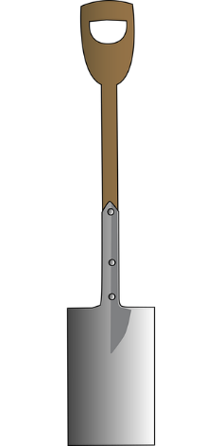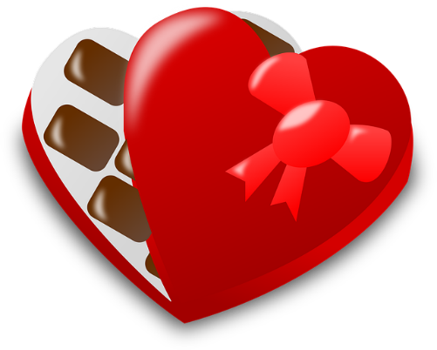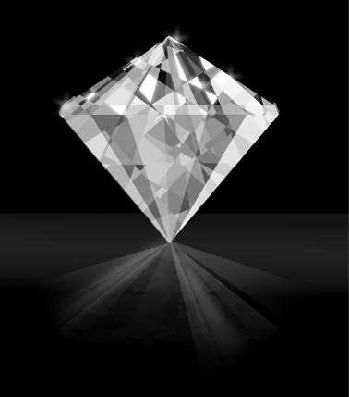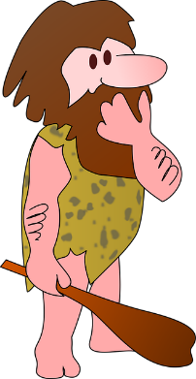

COURT CARDS
- You need a strong image for the court cards. These are just suggestions, feel free to make up your own but make them strong and memorable. Remember the rules for imagining – exaggeration, humour, naughty, sexy, movement, sound.
SPADES: a large spade
KING: a BLACK KING – I use a Pirate King using a spade to dig up his treasure
QUEEN: a BLACK QUEEN - the queen from Snow White with her mirror or Maleficent- Angelina Jolie with her extraordinary horned head-dress
JACK: a BAD BOY – Fresh Prince of Bel-Air Will Smith/Denis the Menace or Prince – the Musician Prince – (a genius and not a Bad Boy)

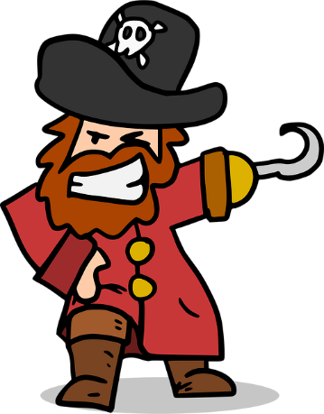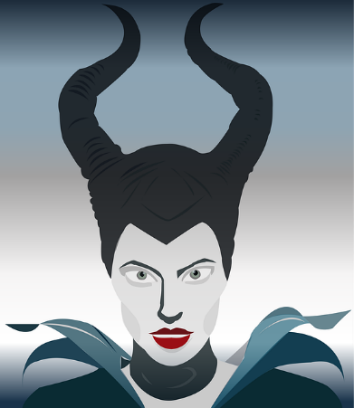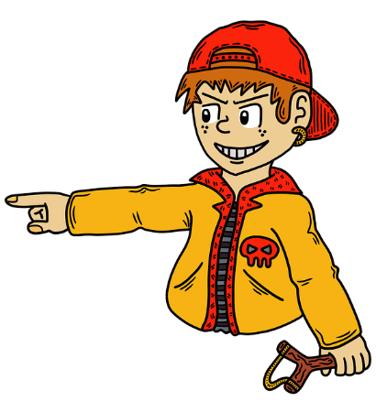

HEARTS: a heart, a heart shaped box of chocolates
KING: The King in Alice in Wonderland who was tiny compared to the Queen. A favourite heartthrob from film or TV or The King, himself Elvis.
QUEEN: fearsome Queen from Alice, shouting ‘off with his head’ – I like this, similar to Elvis with lots of movement or Princess Di in the famous interview where she said she wanted to be known as the Queen of Hearts.
JACK: Prince Harry - smitten with Meghan, any famous heart throb or my favourite: the Frog Prince.
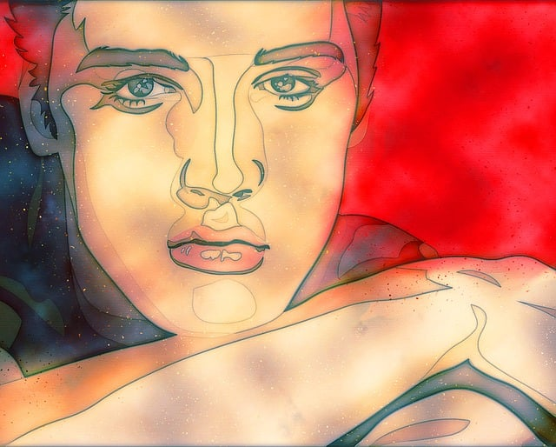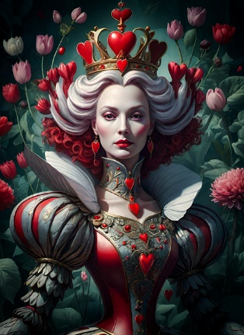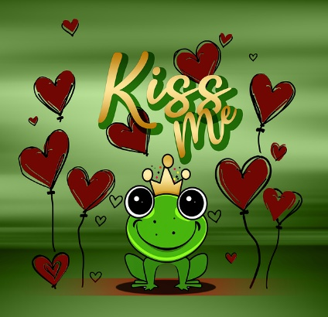

DIAMONDS: diamond, diamond ring
KING: Someone rich and recognisable. Elton John (draped in diamonds), David Beckham, George Cluny
QUEEN: HM Queen Elizabeth wearing the crown jewels
JACK: a rich young man – Ed Sheeran, Justin Bieber.
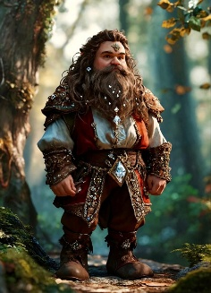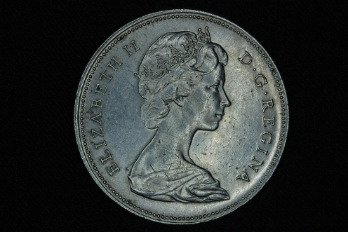

CLUBS: club
KING: Flintstone family – Fred
QUEEN: Donna Summer- Queen of the disco club, or Wilma Flintstone
JACK: Bam Bam (Barney Rubble’s baby son)/John Travolta (Saturday Night Fever)
Don’t forget you can always mix and match so if you choose the Flintstone family to represent Clubs, you can also have Donna Summer or the Bee Gees singing in the background.
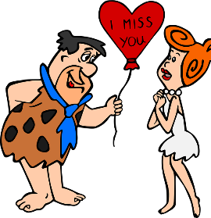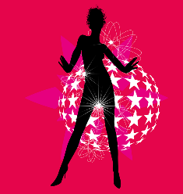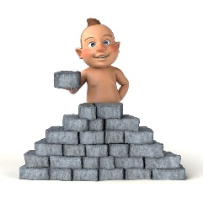

3. Once you have decided on the images for the court cards you need an image for 1 to 10 of the number cards in the suits.
There are 3 numerical systems which turn numbers into images
‘Shape’ (a picture of the shape of numbers)
‘Rhyming’ (a picture which rhymes with the number i.e. 1, Sun, 2, shoe, 3, tree)
‘The Major System’ (images for consonants)
Shape and rhyming are the simplest and hardly need to be learned at all, so use these two systems as you only need to go up to 10. Here is a recap, but you will have already used these images in the early episodes when you memorised the rivers and mountains.
SHAPE SYSTEM
1. PAINTBRUSH/PENCIL/PENIS/FINGER
2. SWAN
3. PREGNANT WOMAN- Beyoncé's- her iconic Instagram post when she was pregnant, Meghan Markle with her moveable bump.
4. SAILBOAT
5. HOOK
6. CHERRY
7. CLIFF
8. HOUR-GLASS/ SNOWMAN/Marilyn Monroe for her 'hourglass' figure
9. BALLOON on a STRING
10 BAT and BALL, this morphed into a cricket match for me.

RHYMING SYSTEM
1. ONE: sun, bun (any cake), gun, fun fair
2. TWO-SHOE: Pooh (Winnie), loo, poo (naughty does work in memory)
3. THREE-TREE: any season, any type of tree. Climb it, sit under it, hang stuff on the branches.
4. FOUR-DOOR: anything can be behind it when it is opened.
5. FIVE-HIVE: see, hear the bees. Smell, taste and touch the honey. Honeycomb.
6. SIX-STICKS: any sort of stick, chopsticks, drumsticks, one you throw to a dog, sticks you put on a bonfire, sticks you use to play games.
7. SEVEN-HEAVEN: angels and fluffy clouds. Angel Delight.
8. EIGHT-GATE: sit on it, open it, see through it, go through it.
9. NINE-LINE, WINE: a washing line, peg things on it, tie up something, race to the finishing line.
10. TEN-HEN: see her, feel her, and hear her! Where does she nest or lay her eggs? What does she lay apart from eggs?
These are just suggested images to get your imagination going.
Now fix the number images to your suits. It might help to use the SHAPE images for the BLACK suits and the RHYME images for the RED suits.
1 (ACE – shape Pencil) SPADES – break a PENCIL with a SPADE
1 (ACE – shape Pencil) CLUBS – break a PENCIL with a CLUB
2 (shape Swan) SPADES – a black SWAN digging with a SPADE
2 (shape Swan) CLUBS – a black SWAN in a night CLUB
3 (shape Pregnant Lady) SPADES – Beyoncé or Meghan Markle DIGGING
3 (shape Pregnant Lady) CLUBS – Beyoncé or Meghan in a nightclub CLUBBING
4 (shape Sail Boat) SPADES – BOAT using a SPADE as an oar
4 (shape Sail Boat) CLUBS – – BOAT caveman in a boat
5 (shape Hook) SPADES – Hang a SPADE on a HOOK
5 (shape Hook) CLUBS – a caveman hangs a CLUB on a HOOK
6 (shape Cherry) SPADES – Cut a CHERRY with a SPADE
6 (shape Cherry) CLUBS – a caveman hangs a CHERRY on his ear

7 (shape Cliff) SPADES – Throw a SPADE off a CLIFF
7 (shape Cliff) CLUBS – Throw a CLUB off a CLIFF
8 (shape Snowman) SPADES – Make a SNOWMAN with a SPADE
8 (shape Snowman) CLUBS – Smash a SNOWMAN with a CLUB
9 (shape Balloon on a String) SPADES – Attach a SPADE to the STRING
9 (shape Balloon on a String) CLUBS – Attach a CLUB to the STRING
10 (shape Bat and Ball) SPADES – Change the BAT for a SPADE
10(shape Bat and Ball) CLUBS – Change the BAT for a CLUB
For the red suits use RHYMING
1 (rhyming Sun) (ACE) HEARTS –Chocolate HEARTS melt in the sun
1 (rhyming Sun) (ACE) DIAMONDS – GUN shoots DIAMONDS, robber RUNS with the DIAMONDS
2 (rhyming Shoe) HEARTS –CHOCOLATE SHOE
2 (rhyming Shoe) DIAMONDS – DIAMOND buckles on a SHOE
3 (rhyming Tree) HEARTS – HEART carved on a TREE, HEARTS hung on a TREE
3 (rhyming Tree) DIAMONDS – DIAMONDS hung on a TREE
4 (rhyming Door) (ACE) HEARTS –Chocolate HEARTS melt in the sun
4 (rhyming Door) (ACE) DIAMONDS – GUN shoots DIAMONDS, robber RUNS with the DIAMONDS
5 (rhyming Hive) HEARTS –CHOCOLATE SHOE
5 (rhyming Hive) DIAMONDS – DIAMOND buckles on a SHOE
6 (rhyming Sticks) HEARTS – Knock Chocolate HEARTS with golf STICKS
6 (rhyming Sticks) STICKS made of DIAMONDS
7 (rhyming Heaven) Angels eat Chocolate HEARTS in HEAVEN
7 (rhyming Heaven) Angels crowned with DIAMOND halos in HEAVEN
8 (rhyming Gate) – CHOCOLATE HEART GATE
8 (rhyming Gate) DIAMONDS – DIAMOND GATE
9 (rhyming Line) HEARTS – Runner crosses the winning LINE: prize of a HEART-shaped box of chocolates
9 (rhyming Line) DIAMONDS – LINE is made of DIAMONDS
10 (rhyming Hen) HEN nesting in a HEART-shaped box of chocolates
10 (rhyming Hen) HEN in a nest of DIAMONDS
Practice with these images for all 52 cards until you are quite confident with them. The fun part comes next in Part 2 when you create a linking story with a random shuffled pack of cards. You will need to be very confident with the images you have created, as the order of the cards will change every time the cards are shuffled.
So do your homework. Trust me, you can do this, amaze your friends, but even more importantly, exercise your imagination. In the next document, I will give you an example of a linking story for a randomly shuffled pack of cards.

